# Saving stream data

Start by deciding what data you are interested in storing. You can go to <http://support.datasift.net/help/kb/rest-api/return-objects> to get an idea of the fields that are available. For convenience a sample is provided below  
**{stream**: **[**

**{**

**interaction**: **{**

**source**: "web"**,**

**author**: **{**

**username**: "jbenths"**,**

**name**: "Jade Bentham♥"**,**

**id**: 290527425**,**

**avatar**: "http://a2.twimg.com/profile_images/1458378128/image_normal.jpg"**,**

**link**: "http://twitter.com/jbenths"

**},**

**type**: "twitter"**,**

**link**: "http://twitter.com/jbenths/statuses/98023947240611840"**,**

**created_at**: "Mon, 01 Aug 2011 13:35:04 +0000"**,**

**content**: "@ode_fashola yeah its getting there, give it another 2 weeks ill be nicely tanned, defo babe.. yates or something"**,**

**id**: "1e0bc4311103a5d0e07460ff1f6f1af0"

**},**

**twitter**: **{**

**in_reply_to_screen_name**: "ode_fashola"**,**

**user**: **{**

**name**: "Jade Bentham♥"**,**

**description**: "Live, Love, Laugh.."**,**

**location**: "London"**,**

**statuses_count**: 121**,**

**followers_count**: 40**,**

**friends_count**: 65**,**

**screen_name**: "jbenths"**,**

**lang**: "en"**,**

**id**: 290527425

**},**

**mentions**: **[**"ode_fashola"**],**

**id**: "98023947240611840"**,**

**text**: "@ode_fashola yeah its getting there, give it another 2 weeks ill be nicely tanned, defo babe.. yates or something"**,**

**source**: "web"**,**

**in_reply_to_status_id**: "98016795344121856"**,**

**in_reply_to_user_id**: "309863213"**,**

**created_at**: "Mon, 01 Aug 2011 13:35:04 +0000"

**},**

**language**: **{**

**tag**: "en"

**},**

**rapleaf**: **{**

**gender**: "Male"

**},**

**klout**: **{**

**score**: 18**,**

**network**: 10**,**

**amplification**: 10**,**

**true_reach**: 8**,**

**slope**: 0**,**

**class**: "Dabbler"

**},**

**salience**: **{**

**content**: **{**

**sentiment**: 0

**}**

**}**

**}**

**]**

**}**

The next step is to create a table in your preferred database with columns to represent the data you want to store. Below, is a screenshot of the table I’ve designed for this example. You can use a tool such as MySQL Workbench (<http://wb.mysql.com/>) or write the SQL statements by hand if you prefer.

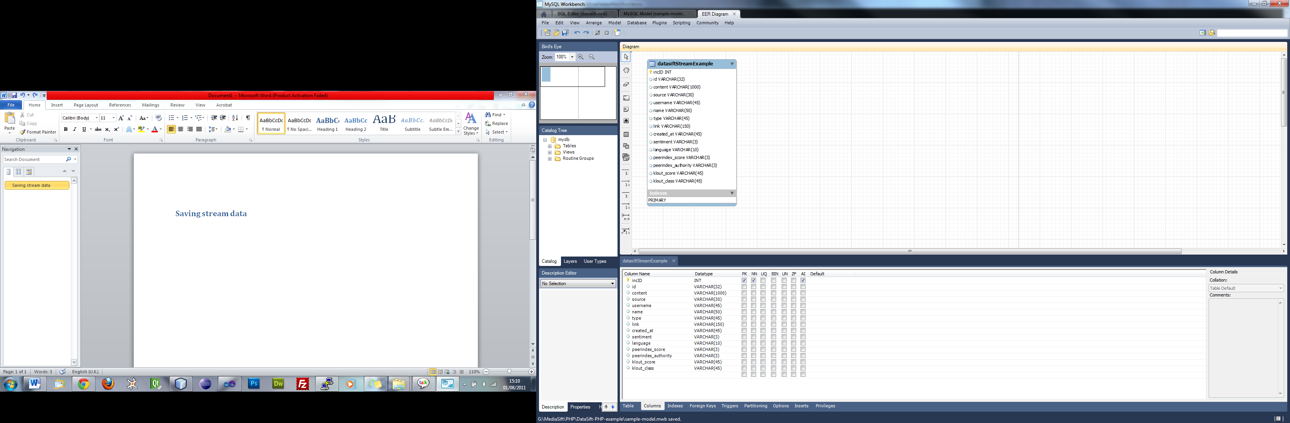

The sample SQL statements needed to generate the database table is as follows:  
CREATE TABLE IF NOT EXISTS `courtney0`.`datasiftStreamExample` ( `incID` INT NOT NULL AUTO_INCREMENT , `id` VARCHAR(32) NULL , `content` VARCHAR(1000) NULL , `source` VARCHAR(30) NULL , `username` VARCHAR(45) NULL , `name` VARCHAR(50) NULL , `type` VARCHAR(45) NULL , `link` VARCHAR(150) NULL , `created_at` VARCHAR(45) NULL , `sentiment` VARCHAR(3) NULL , `language` VARCHAR(10) NULL , `peerindex_score` VARCHAR(3) NULL , `peerindex_authority` VARCHAR(3) NULL ,  
 `klout_score` VARCHAR(45) NULL , `klout_class` VARCHAR(45) NULL , PRIMARY KEY (`incID`) )ENGINE = InnoDB;

Execute this on your mysql server to create the sample table structure used in the example.

The code in database.php will extract the information and put it into the newly created table.